MOHAN SPINTEX SHORT INDIUSTRAIL VISIT REPORT

AS A PART OF INDUSTRY ACADEMIA INTERACTION DEPARTMENT OF MBA , ANDHRA LOYOLA COLLEGE CONDUCTED A SHORT INDUSTRIAL VISIT FOR AMBA SECTION –I STUDENTS ON 15-07-2023.50 AMBA STUDENTS ALONG WITH DEPARTMENT STAFF Dr.A.MADHURI AND Dr.M.SHIREESHA VISITED MOHAN SPINTEX INDIA LIMITED ,REMALLE UNIT. STUDENTS OBSERVED THE ENTIRE PLANT-LAYOUT, DIFFERENT OPERATIONS.STUDENTS INTERACTED WITH COMPANY OFFICIALS, ACQUIRING FIRST HAND KNOWLEDGE AND UNDERSTANDING OF THE VARIOUS PROCESSES

STUDENTS OBSERVATIONS DURING THEIR VISIT:

- RAW MATERIAL HANDLING:
- CARDING AND COMBING
- DRAWING AND ROVING
- SPINNING
- QUALITY CONTROL
- PACKAGING AND DISPATCH
- COMPANY’S CSR PRACTICES
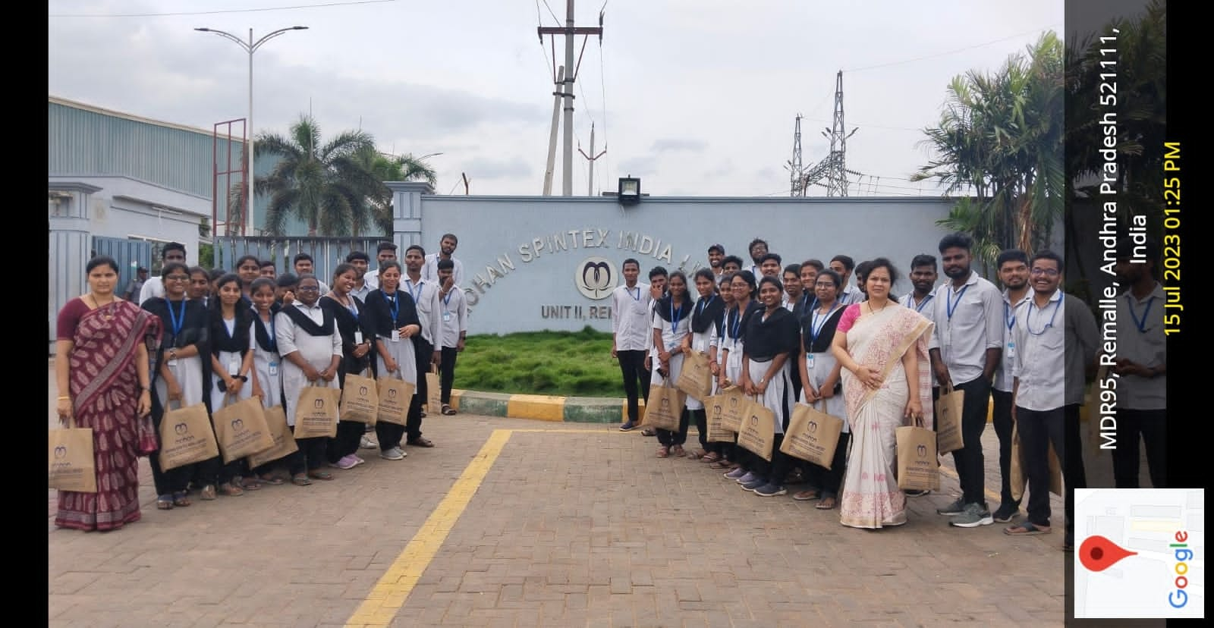
MBA STAFF AND STUDNETS AT MOHAN SPINTEX INDIA LIMITED
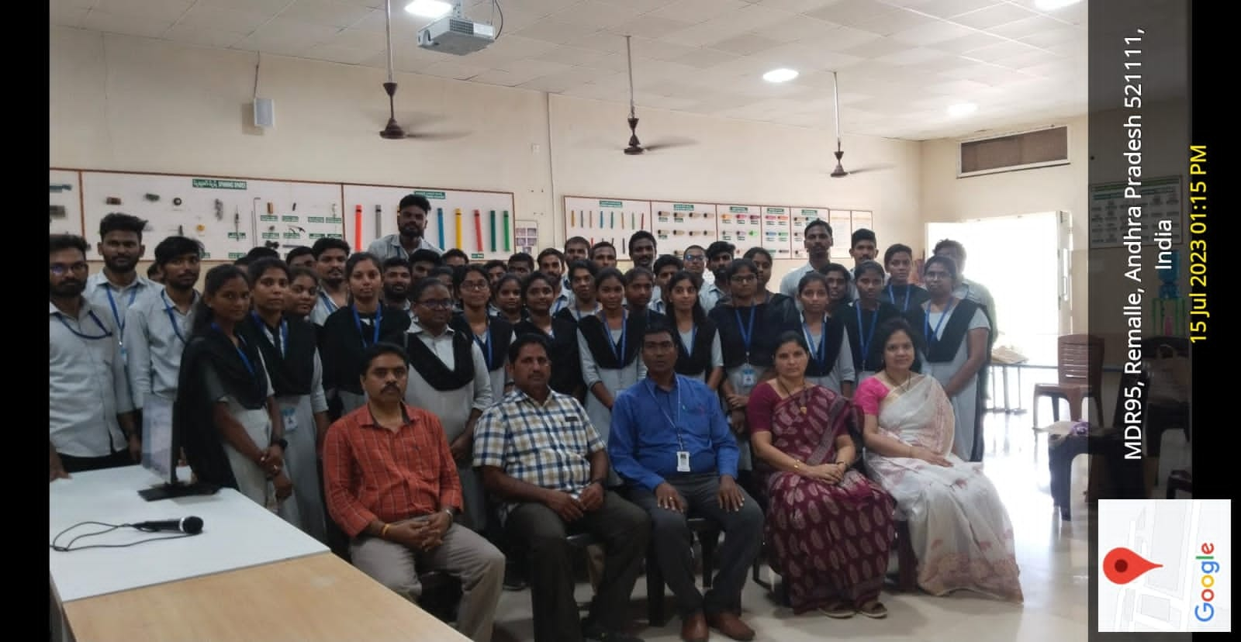
MBA STAFF AND STUDNETS WITH MOHAN SPINTEX INDIA LIMITED OFFICIALS
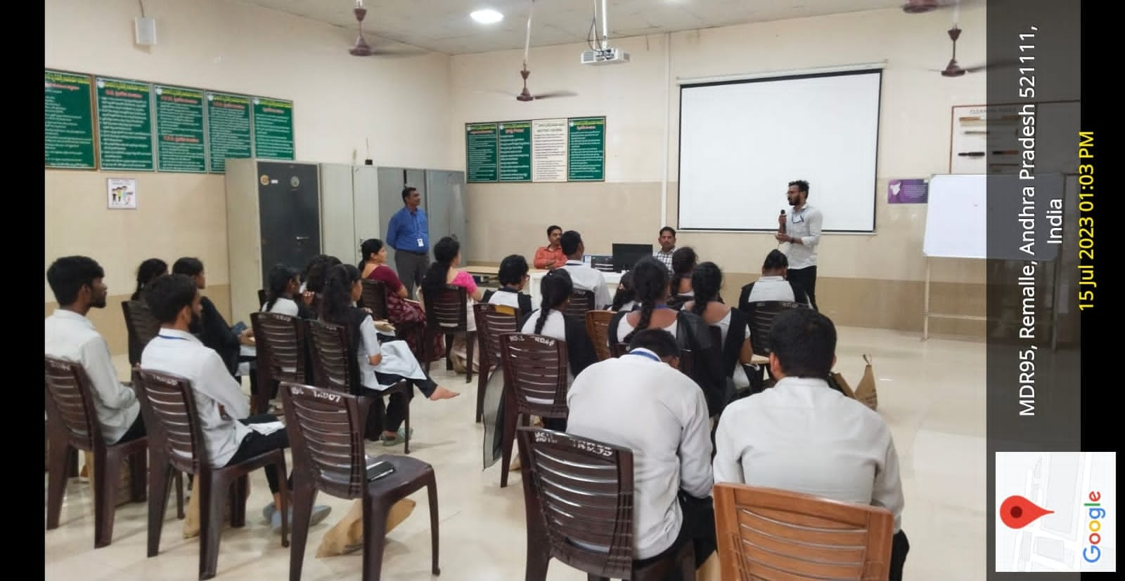
AMBA STUDNETS INTERACTION WITH MOHAN SPINTEX INDIA LIMITED OFFICIALS

